Assignment-4

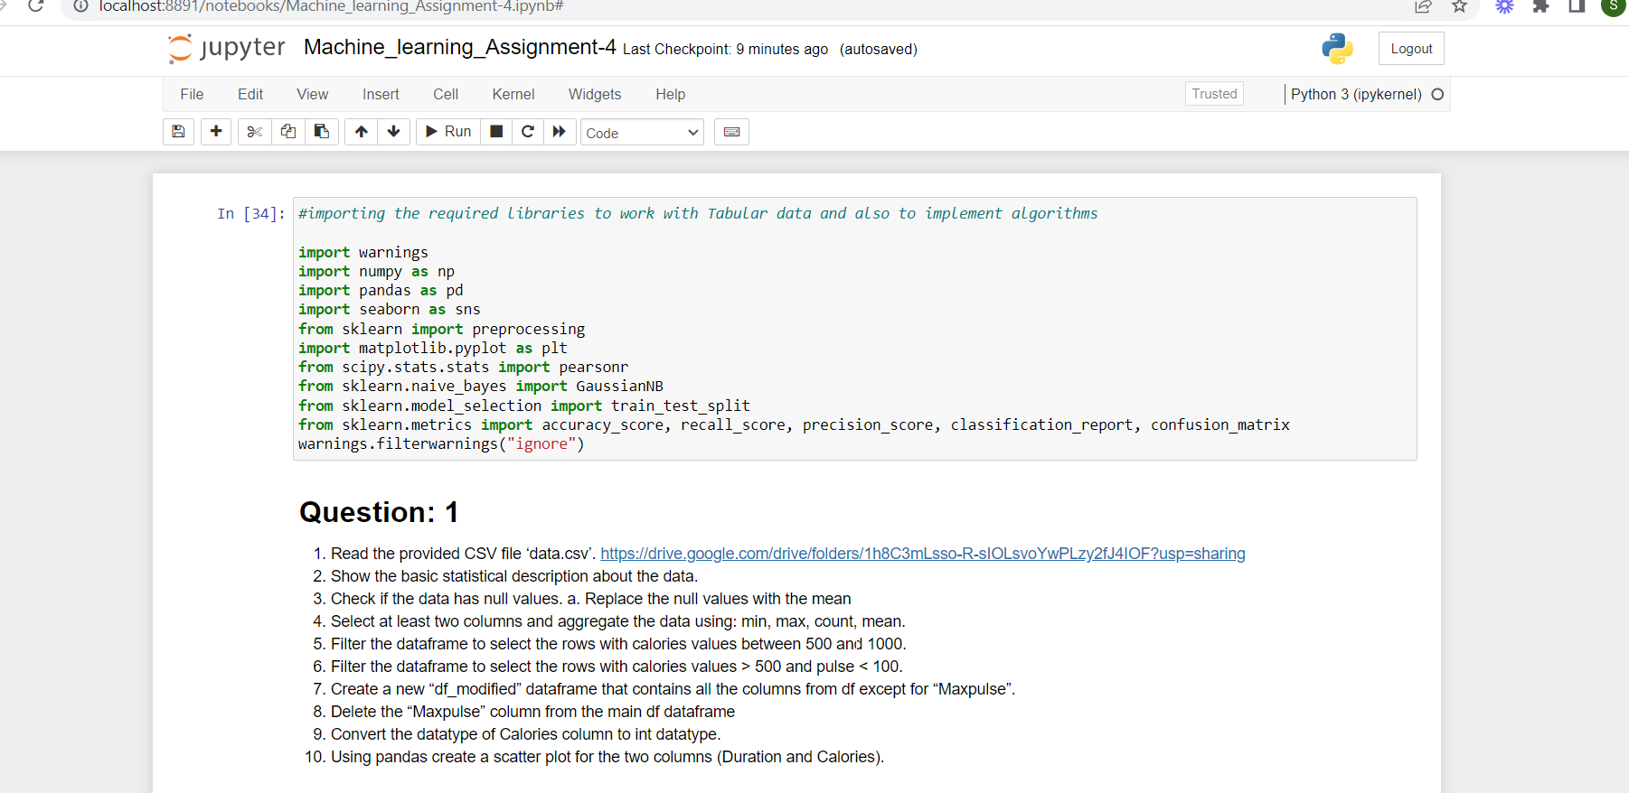

Import the required libraries to work.

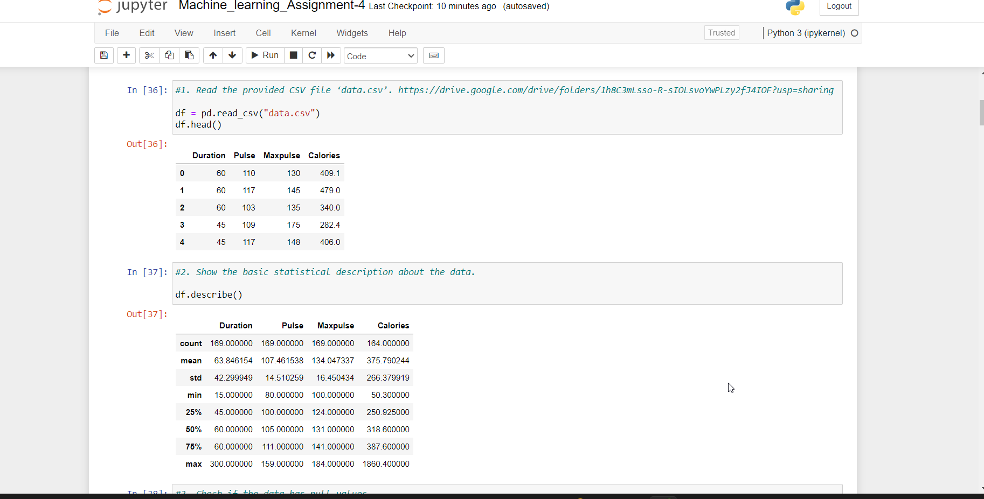

read the csv file provided and show statistical data.

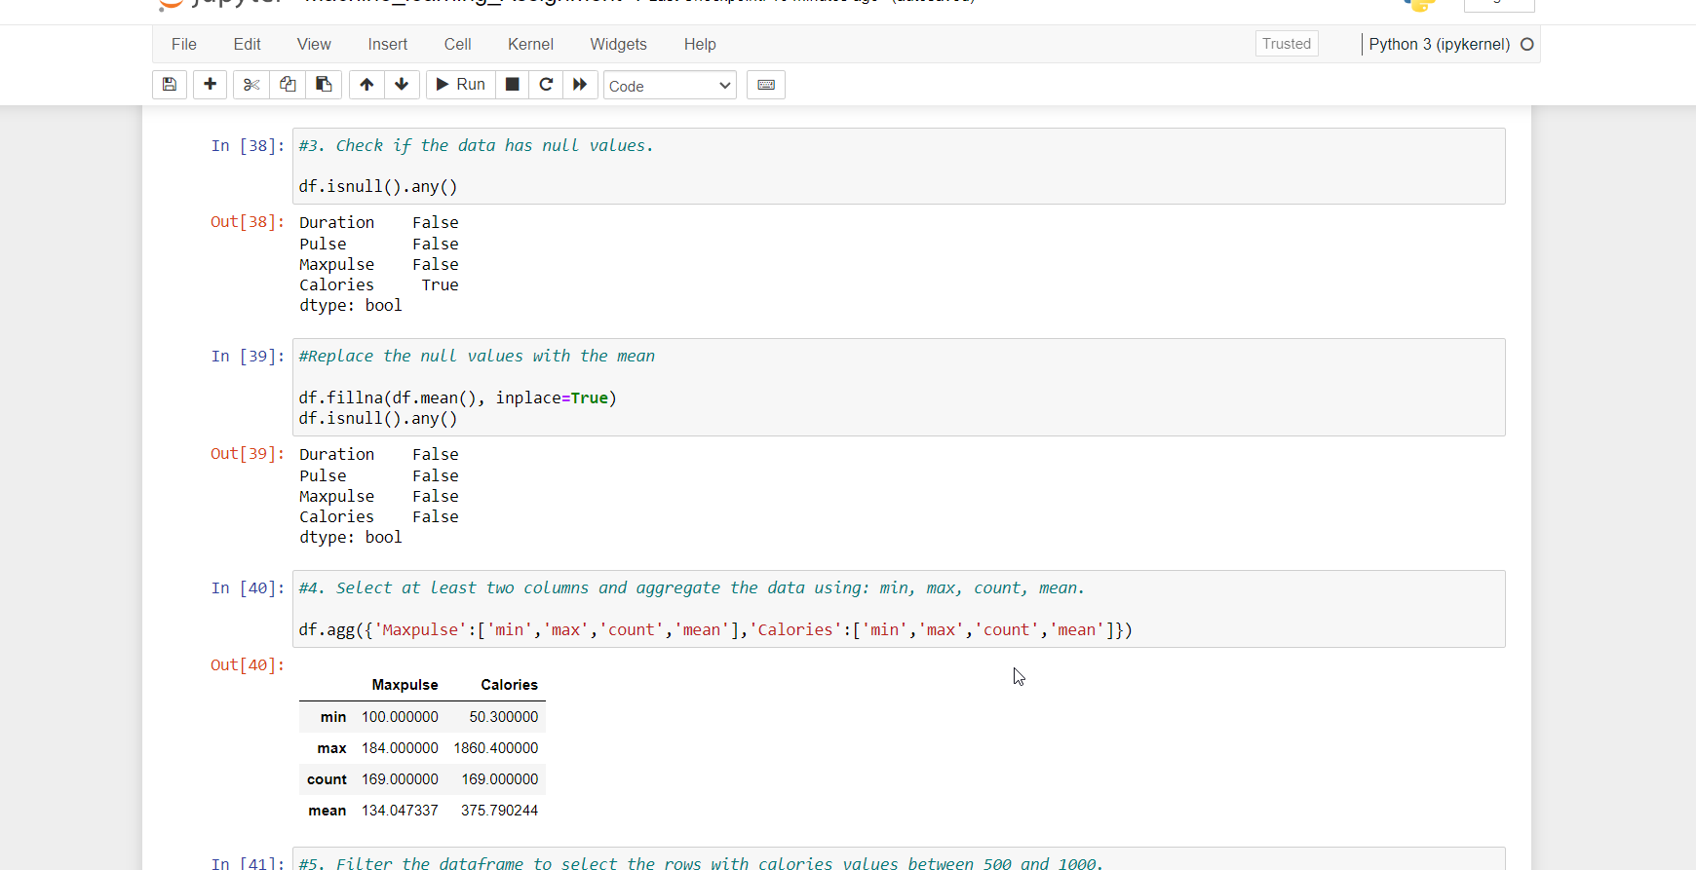

Check the null values

Replace the null values with mean

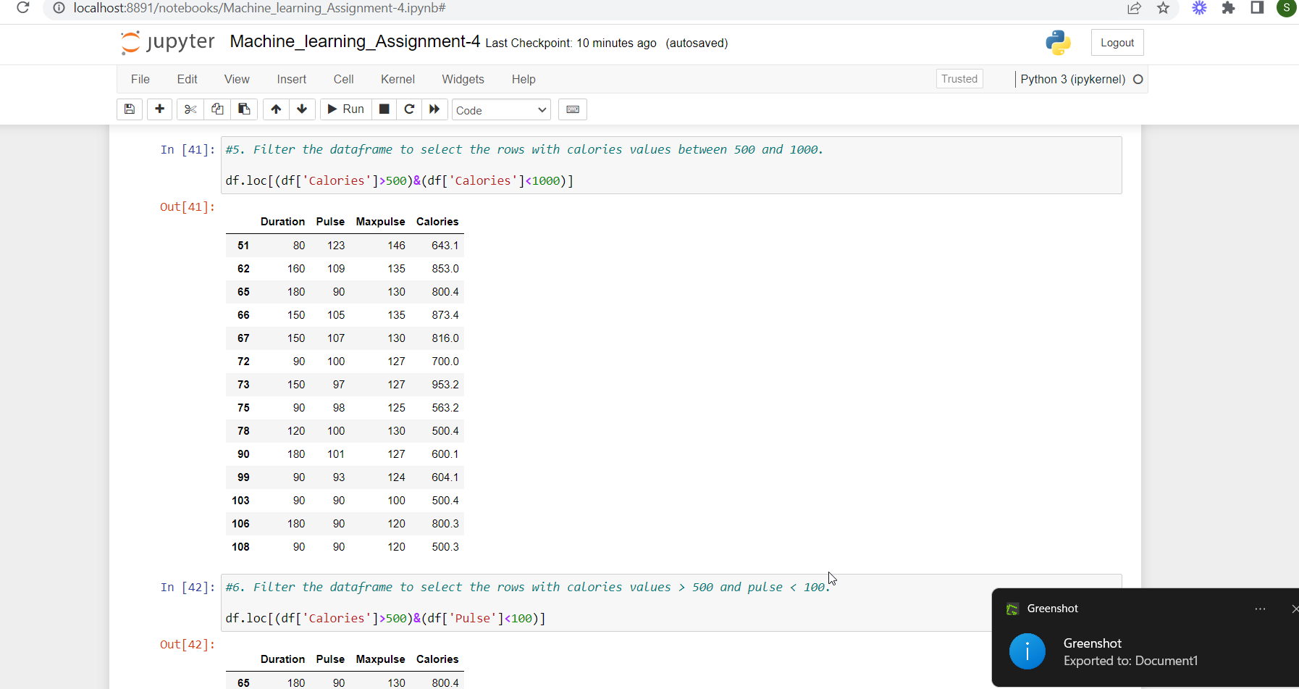

filter the dataframe to select the rows with calorie value b/w 500 and 1000.

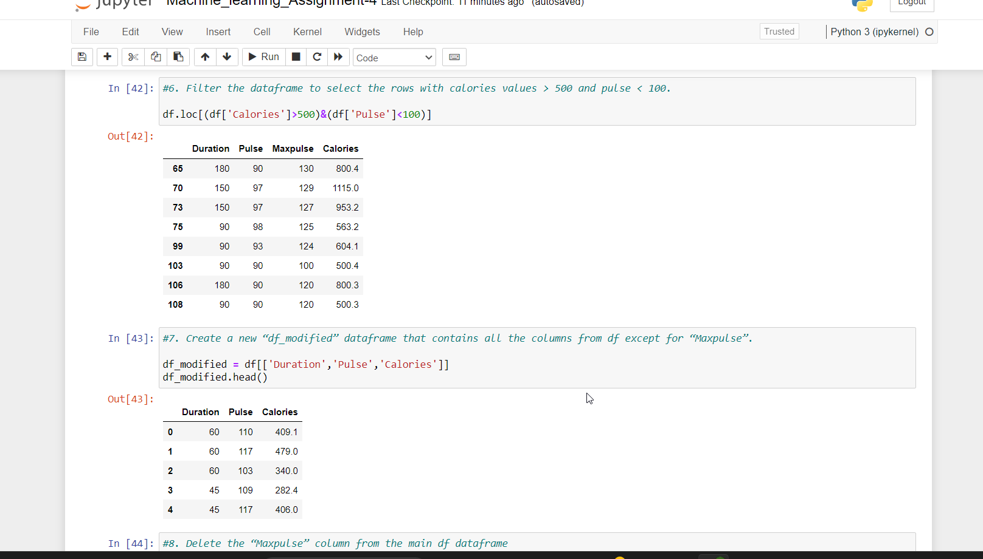

Create dataframe and maxpulse and delete it

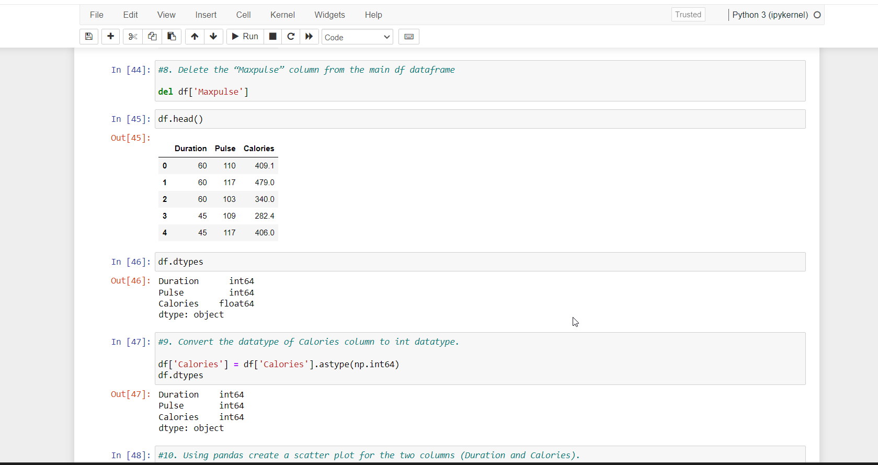

Convert datatype of calories.

Using pandas create a scatter plot for duration and calories

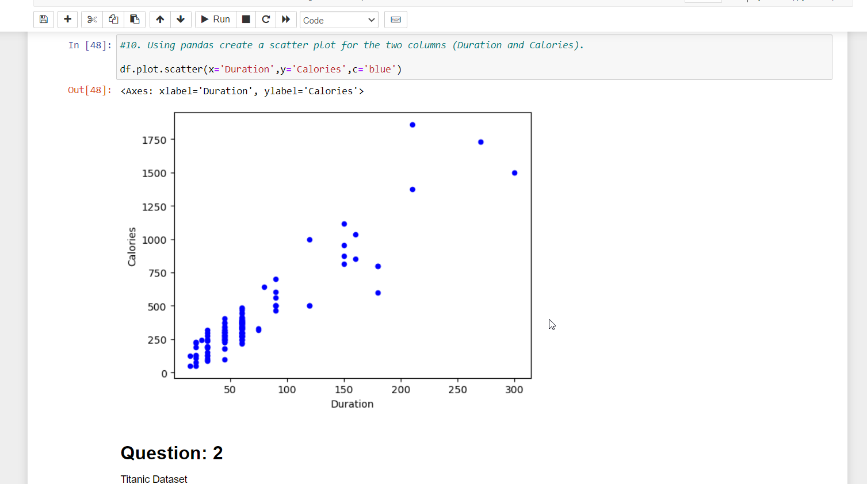

Find the correlation.

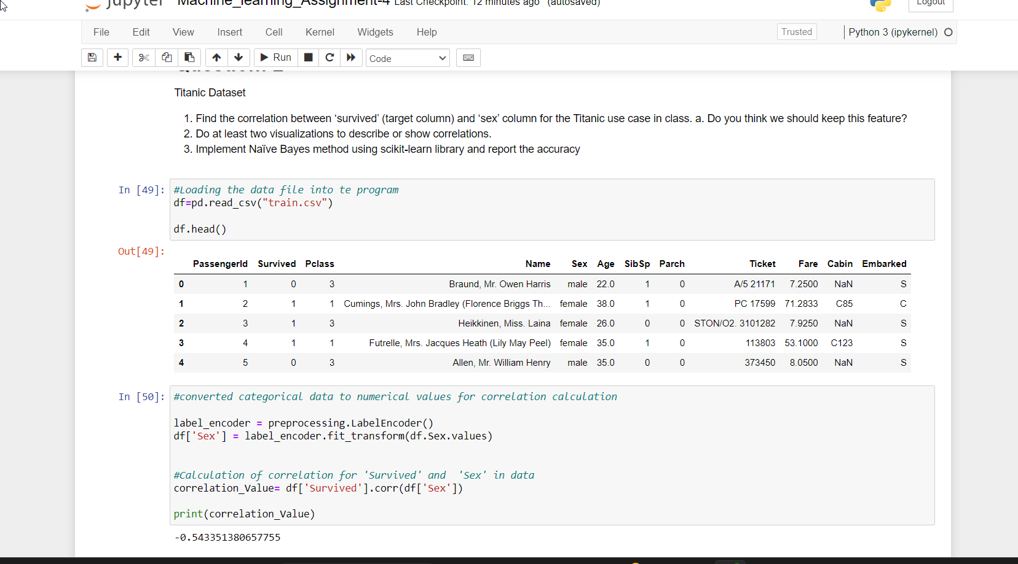

**the accuracy is just 54%.so it is not necessary**

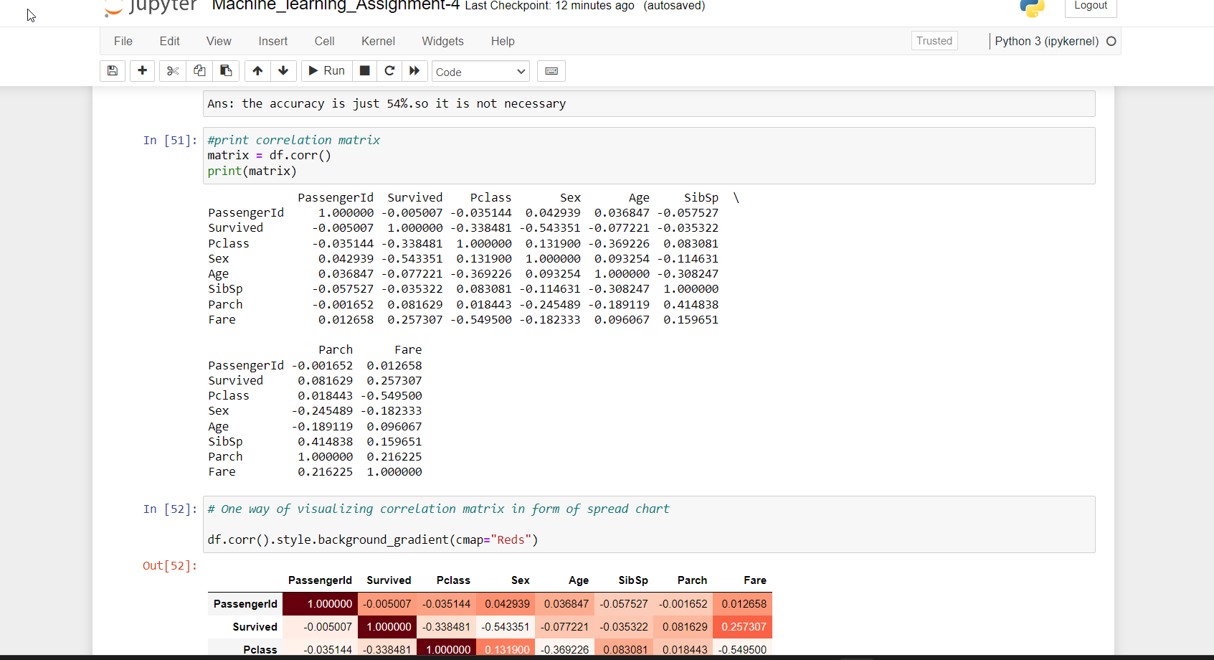

Print correlation matrix and also visualizing in form of spread sheet

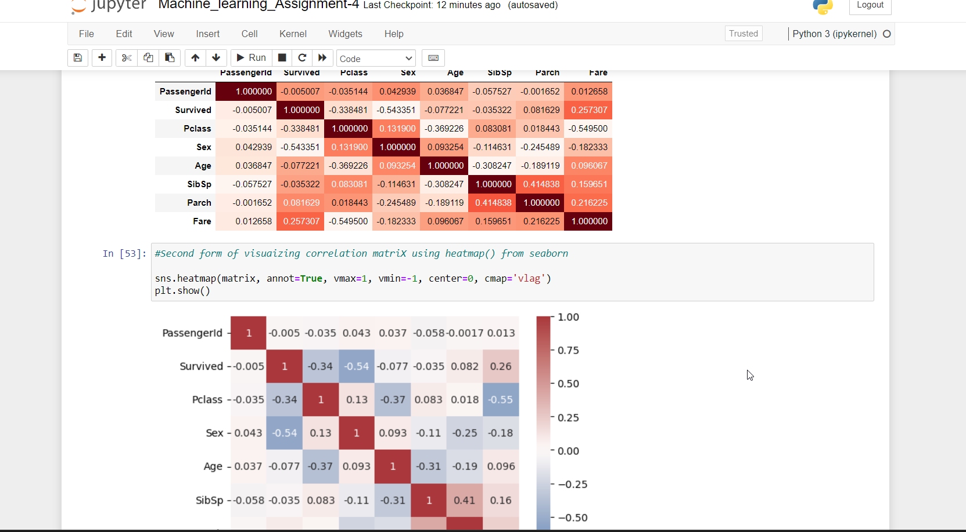

Visualizing correlation matrix using heatmap() from seaborn

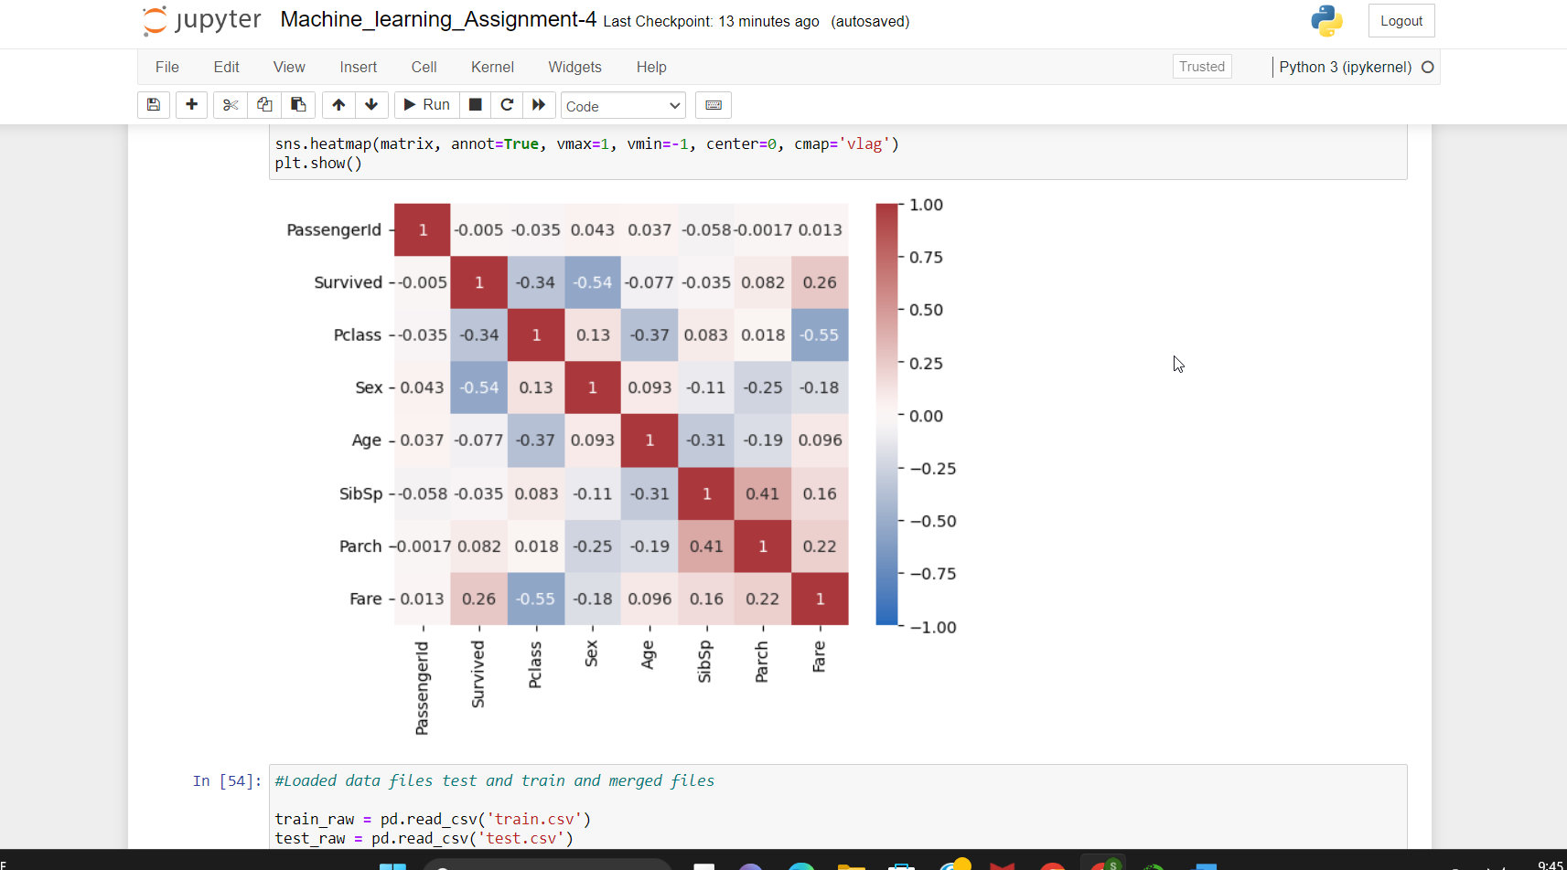

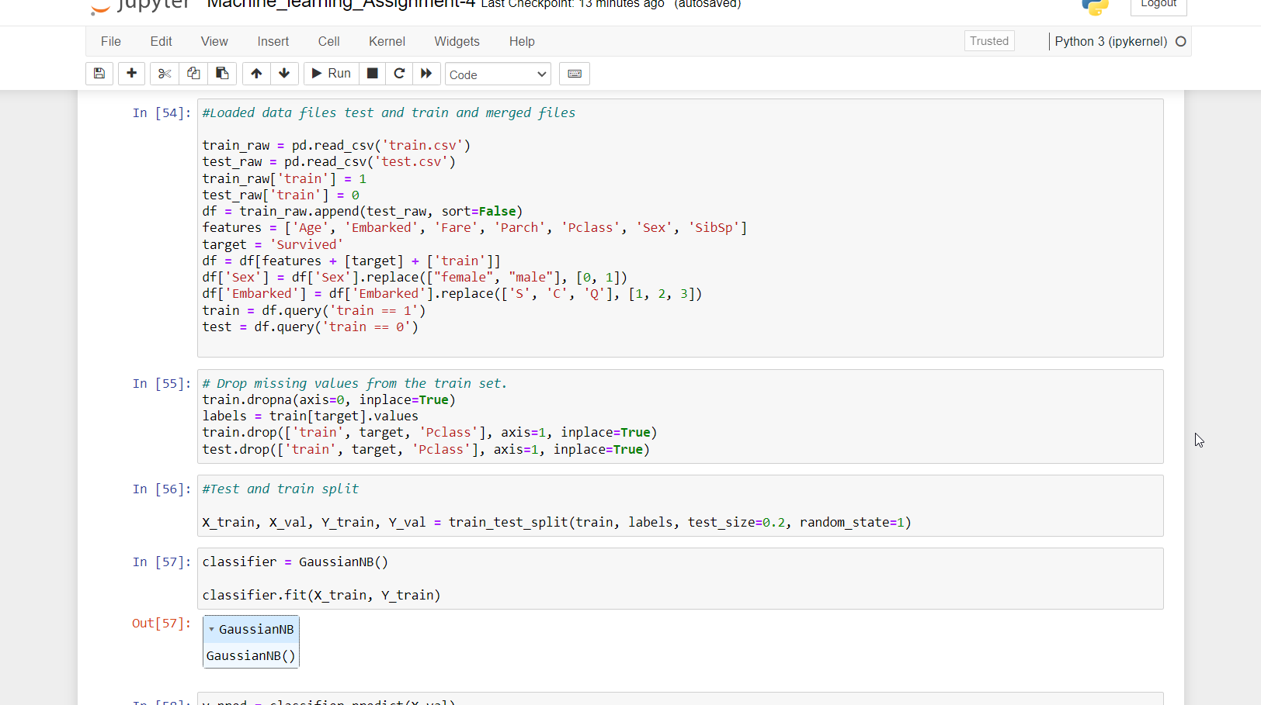

Load data file test and train and merged files

Drop missing values from the train set

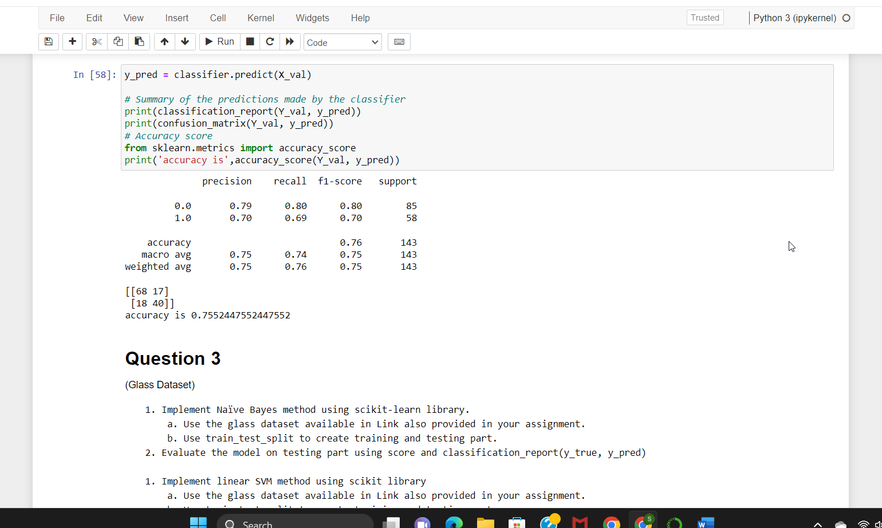

Make prediction chart and accuracy.

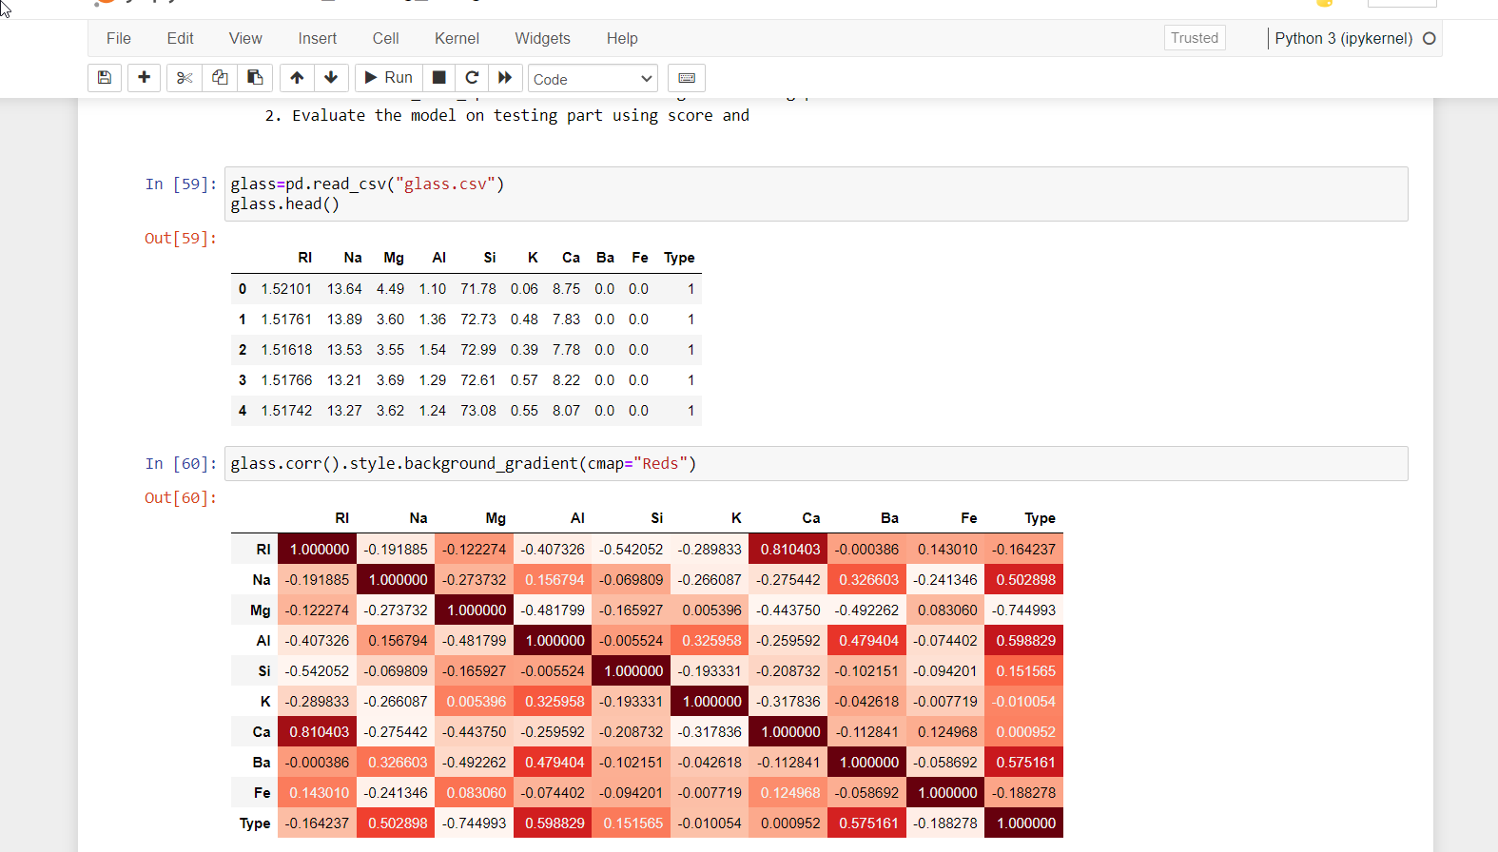

Print visualing chart using heat map

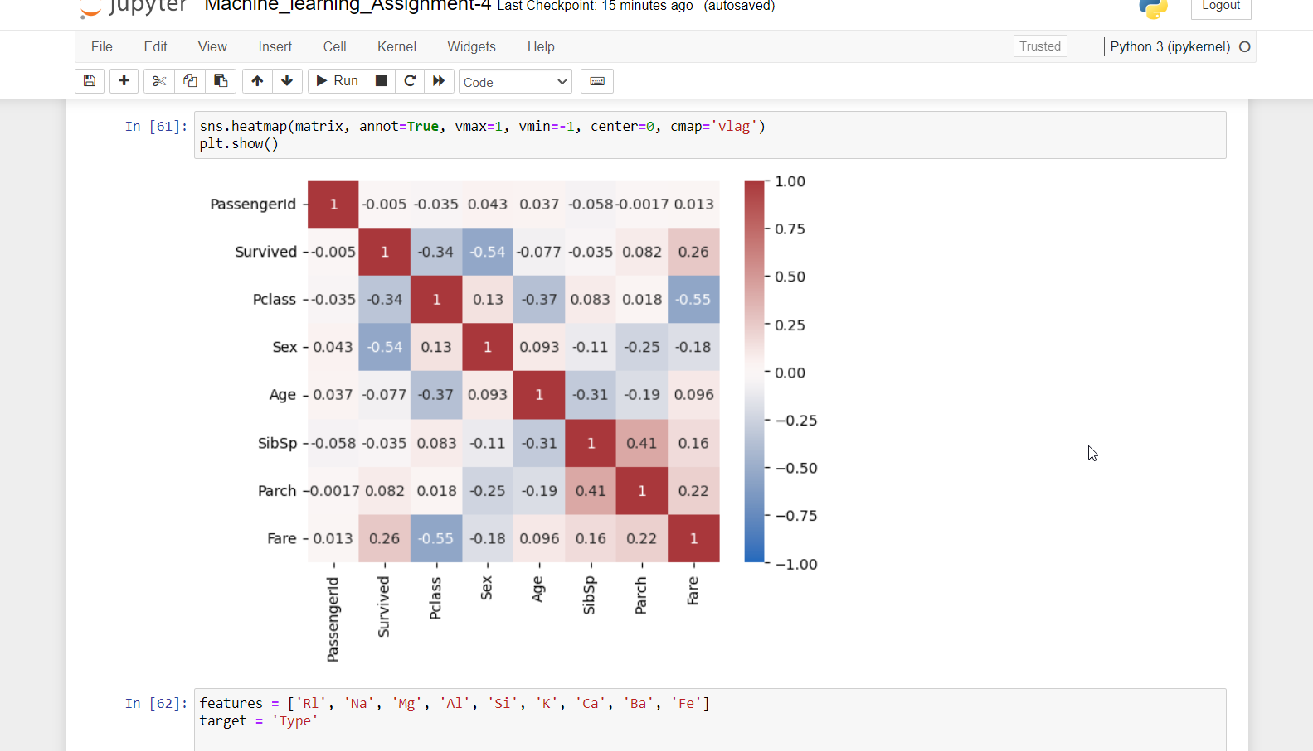

Summarize the prediction

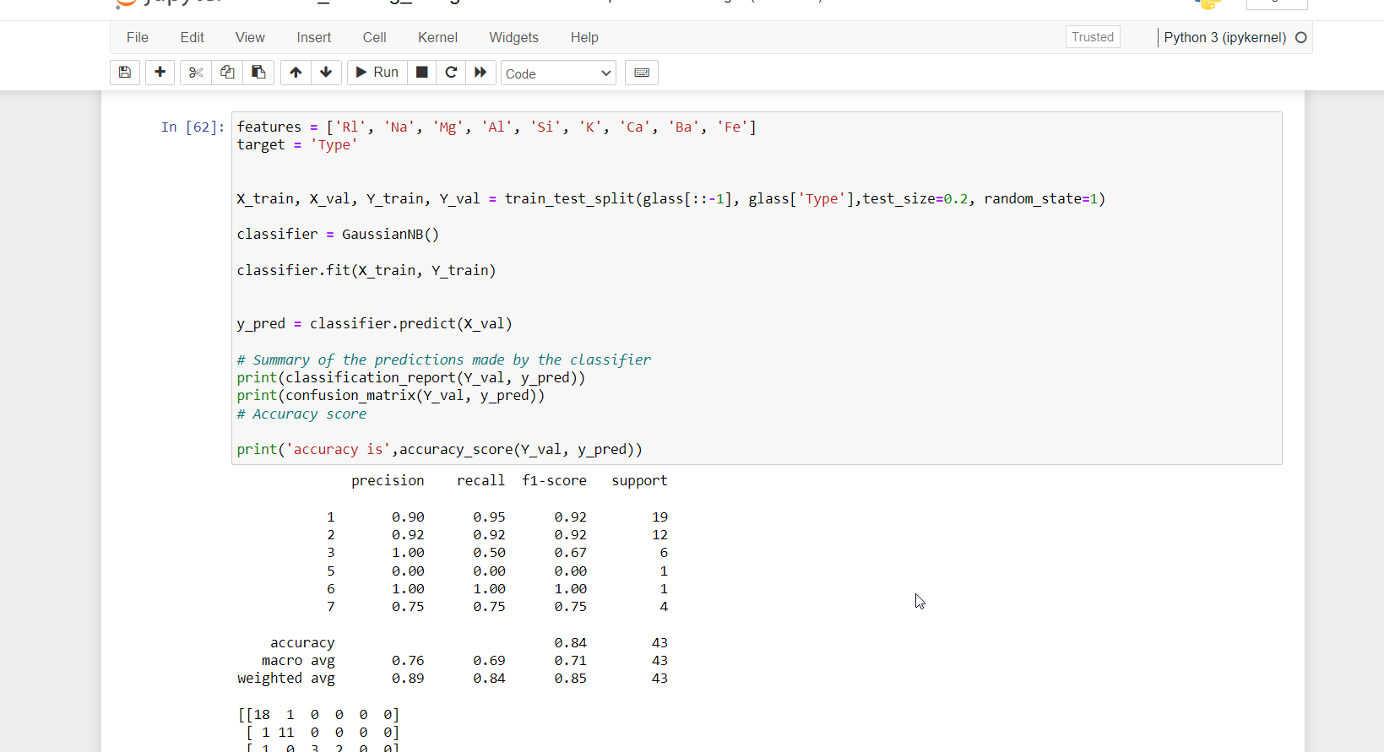

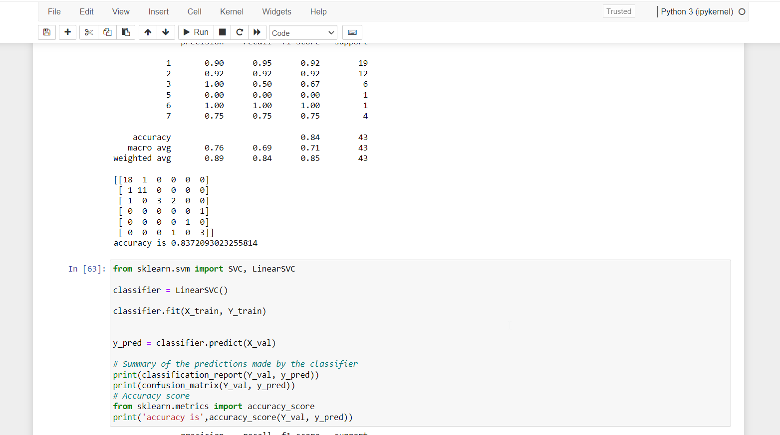

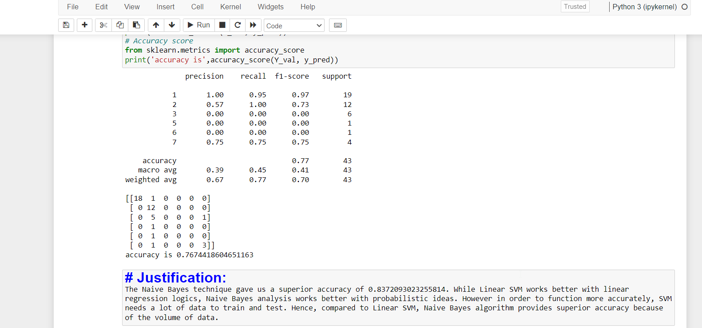

The Naive Bayes technique gave us a superior accuracy of 0.8372093023255814. While Linear SVM works better with linear regression logics, Naive Bayes analysis works better with probabilistic ideas. However, in order to function more accurately, SVM needs a lot of data to train and test. Hence, compared to Linear SVM, Naive Bayes algorithm provides superior accuracy because of the volume of data.

Video link: <https://www.loom.com/share/081b23b321a54147a0fa5ae683848bb4>

Github link: <https://github.com/kadiresanjayreddy/machinelearningAssignment-4>